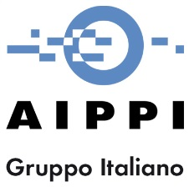
17 Giugno 2016
Centro Congressi "Le Stelline – Sala MANZONI” Corso Magenta 61, Milano

Seminar
New Trends in IP Legislation and Legal Procedures: a Comparison between US and Europe

9:00 Registration of participants
9:30 Welcome to AIPLA delegation
ENRICO ZANOLI – Zanoli & Giavarini S.p.A. – President of Institute of Italian Patent and Trademark Attorneys
FRANCESCO MACCHETTA – Bracco Imaging S.p.A. – President of AICIPI
RENATA RIGHETTI – Bugnion S.p.A. – President of AIPPI Italian Group
9:40 Introduction
CESARE GALLI – IP Law Galli
9:50 Update on patentability of software: the most recent case law and doctrine
RAYMOND FARRELL - Carter, Deluca, Farrel & Schmidt, LLP
LUCIANO BOSOTTI- Buzzi, Notaro & Antonielli d'Oulx S.r.l.
10:30 Means-plus-function claim interpretation: history and updates after Williamson
THERESA STADHEIM - Schwegman Lundberg & Woessner
ELISABETTA PAPA – Società Italiana Brevetti S.p.A.
11:10 Recent Legislation on U.S. Trade Secrets Law - U.S. Design Patents: Where Are We?
LINDA SHUDY LECOMTE – Arent Fox LLP
GUALTIERO DRAGOTTI – DLA Piper
11:50 Interesting Trademark Cases in the US 2015
KATHLEEN LEMIEUX – BLG-Borden Ladner Gervais
SIMONA LAVAGNINI - LGV Avvocati
12:30 Conclusions

